**Assignment -4**

|  |  |
| --- | --- |
| Assignment Date | 30 OCTOBER 2022 |
| Student Name | S.NITHYAKALYANI |
| Student Roll Number | 913119106073 |
| Maximum Marks | 2 Marks |

### **PROBLEM STATEMENT: IOT BASED** Signs With Smart Connectivity For Better Road Safety

**QUESTION: Write code and connection in wokwi for ultrasonic sensor. Whenever distance is less than 100cm and send “alert” to ibm cloud and display in device recent events.**

**WOKWI LINK:**

<https://wokwi.com/projects/347620137102213714>

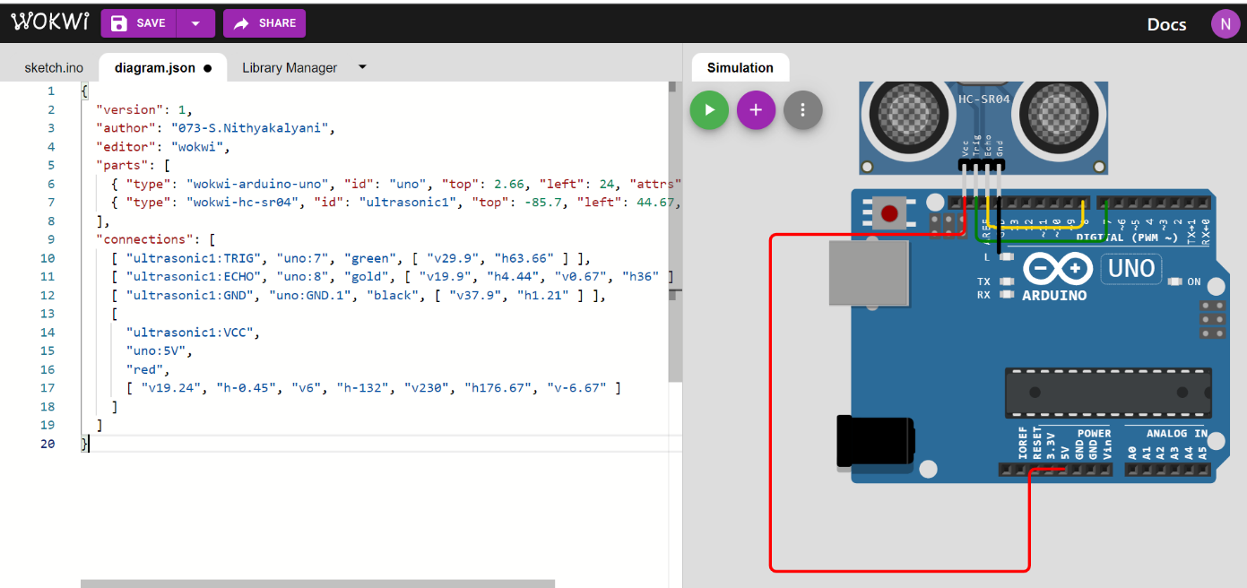

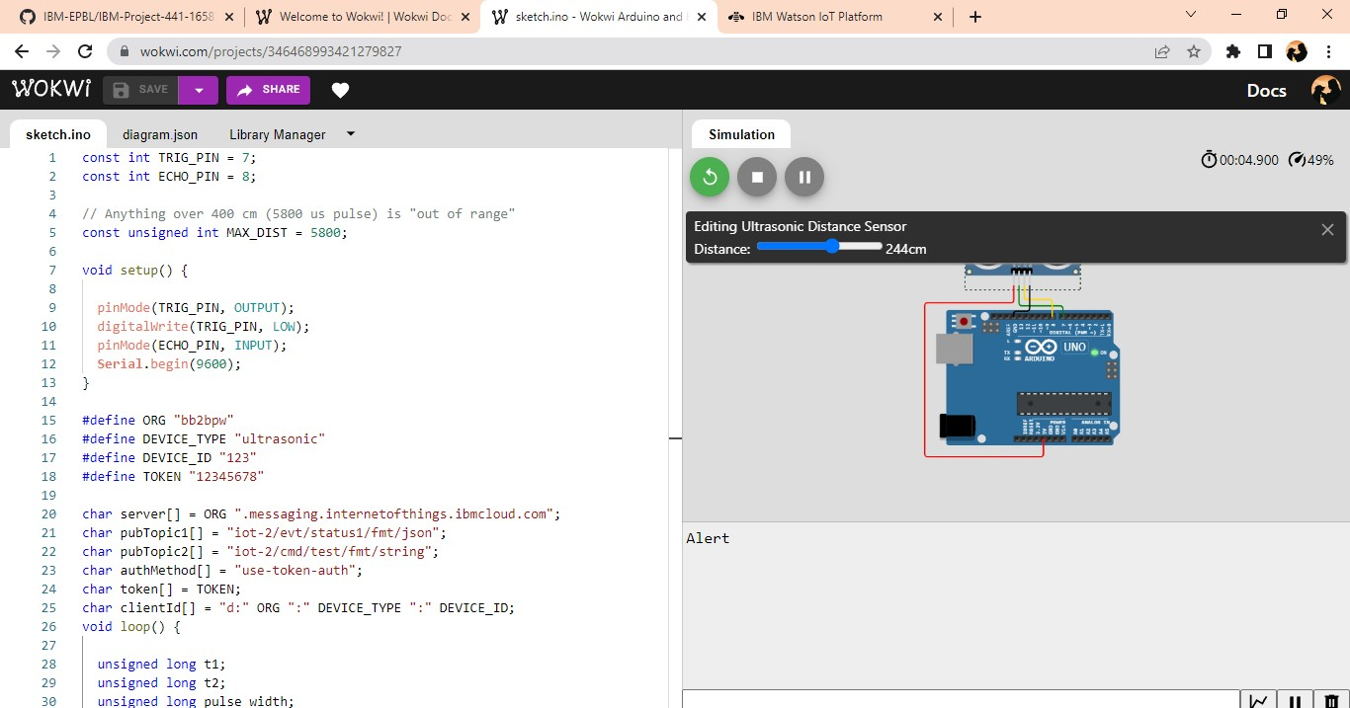

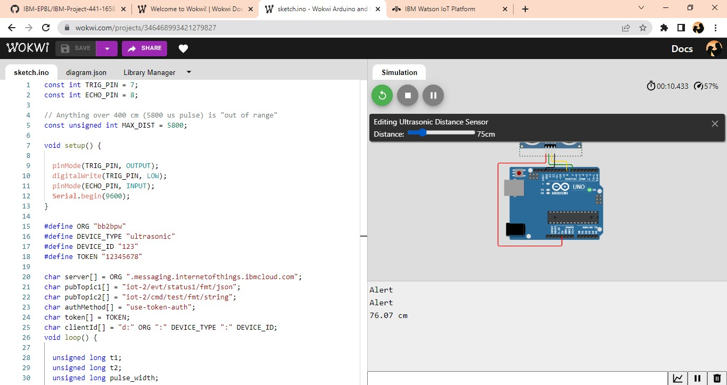

IBM CLOUD:

